Munson’s Pickles and Preserves Farm Retention Labels & Examples

The purpose of these documents is to educate on when and how to govern data for either compliance or regulatory requirements. The same labels apply across Outlook, Outlook on the web, SharePoint, OneDrive, O365 Groups, Public Folders, Teams and Yammer. Munson's Pickles and Preserves Farm want to prevent our crown jewels, work on most current data, and remove or discard data that is no longer needed. We understand that all data is not the same and have many options for each use case internally.

Retention labels & apps supported in Munson's Pickles and Preserves Farm
Outlook

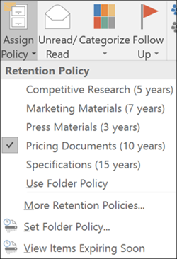

Outlook on the web
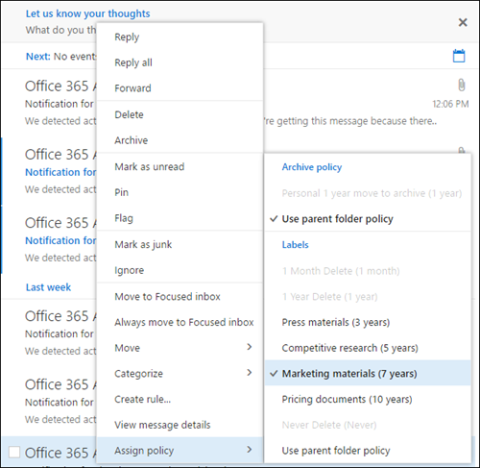

SharePoint and OneDrive
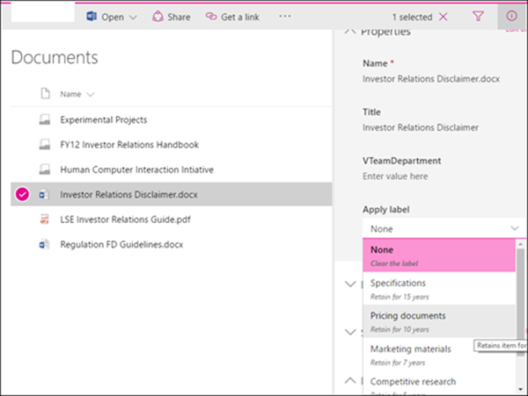

Note: No current user interaction or interface with Yammer, Teams, O365 groups

Labels color coded for examples in supporting documentation to illustrate applying to items to comply with Munson’s information governance policies.

Munson's Pickles and Preserves Farm Retention Labels:

• 1 Week
• 1 Month
• 1 Year
• 5 Year
• Never Delete

1

Week 1
A business should not keep the data for longer than is needed and the determination is dependent on the business needs. Below are examples only.
Use Case for label
1. You are writing an email (using your work provided device) to a friend and want to share photos from your last vacation.
2. You are planning a weekend getaway with your spouse and sharing the brochure over email.
3. You are writing a mail requesting updated car insurance rates.

Examples of data commonly classified as 1 Week include but is not limited to:
- Manufacturing Industry: Personal, not related to work
- Retail Industry: Personal, not related to work
- Government Agency: Personal, not related to work
- Financial Industry: Personal, not related to work
- Healthcare Industry: Personal, not related to work
- Commercial Industry: Personal, not related to work

1 Month
A business should not keep the data for longer than is needed and the determination is dependent on the business needs. Below are examples only.
Use Case for label
1. Responding to a customer regarding an in-market product query
2. Links to publicly available marketing campaigns
3. Sharing links to externally posted jobs.

Examples of data commonly classified as 1 Month include but is not limited to:
- Manufacturing Industry: Job description
- Retail Industry: Recordings
- Government Agency: Court cases
- Financial Industry: Letters and books
- Healthcare Industry: Photographs
- Commercial Industry: Maps

1 Year
A business should not keep the data for longer than is needed and the determination is dependent on the business needs. Below are examples only.
Use Case for label
1. Newsletter for the organization
2. New Employee Orientation training content or email that is updated yearly
3. Customer product warranty information

Examples of data commonly classified as 1 Year include but is not limited to:
- Manufacturing Industry: Name
- Retail Industry: Height
- Government Agency: Address
- Financial Industry: Age
- Healthcare Industry: Signature
- Commercial Industry: General information forms

5 Year
A business should not keep the data for longer than is needed and the determination is dependent on the business needs. Below are examples only.
Use Case for label
1. A functional specification by Munson's Pickles and Preserves Farm employees
2. Tax records
3. A mail from Munson's Pickles and Preserves Farm Senior Leadership Team on new compliance guidance.

Examples of data commonly classified as 5 Year include but is not limited to:
- Manufacturing Industry: Vendor bid information.
- Retail Industry: Non-disclosure agreements
- Government Agency: Joint venture agreements
- Financial Industry: Bank account
- Healthcare Industry: Patient confidentiality agreements
- Commercial Industry: Proprietary computer software

Never Delete
A business should not keep the data for longer than is needed and the determination is dependent on the business needs. Below are examples only.
Use Case for label
1. Contacting your Human Resources with a sensitive concern
2. A email from leadership on the upcoming quarterly performance and guidance
3. List of potential candidates for an open position for the board of directors

Examples of data commonly classified as Never Delete include but is not limited to:
- Manufacturing Industry: Business operations or inventory figures
- Retail Industry: Competitive research
- Government Agency: Security clearance
- Financial Industry: Banking information
- Healthcare Industry: Medical research data
- Commercial Industry: Product specifications

