FY19 Intro to Databricks Hack – Attendee Guide
  - Introduction to using Spark on Azure Databricks

Goals
Most challenges observed by customers in these realms are in stitching multiple services together. As such, where possible, we have tried to place key concepts in the context of a broader example.

Once all hackathon challenges are completed, you should be able to:
- Create an Azure Databricks cluster
- Create Azure Databricks workspace and notebook for data exploration
- Understand the difference between Spark 1 and Spark 2 (RDD API vs. Dataframe API)
- How to use Spark SQL API to wrangle datasets using a familiar syntax

Background Knowledge
This hackathon is meant for data engineers & data scientists on Azure. Previous experience with the following may be helpful but is not required:
  - Spark
  - Azure HD Insight
  - Python
  - Jupyter notebooks

Introduction

In this challenge, you will provision a Databricks workspace and a Spark cluster. You will then interact with the Spark
cluster & begin to explore data interactively.

Getting Started:
To complete the challenges, you will need the following:
• A web browser
• A Microsoft account
• A Microsoft Azure subscription
• A Windows, Linux, or Mac OS X computer
• Azure Storage Explorer
• Microsoft Teams (challenge datasets / scripts are loaded into files section on Teams)

Note: To set up the required environment for the challenge, follow the instructions in the Setup document for this workshop.

Pre-Requisites (completed during workshop)
Note: If you already have an Azure Databricks Spark cluster and an Azure blob storage account, you can
skip this section.

Provision a Databricks Workspace
1. In a web browser, navigate to http://portal.azure.com, and if prompted, sign in using the
Microsoft account that is associated with your Azure subscription.
2. In the Azure portal, create a new Azure Databricks workspace
* helpful tips:
      - Resource Group: Create a new resource group (it will help when cleaning up resources at the end of hackathon)

Provision a Storage Account
1. Create a new storage account
• helpful tips:
      - general storage type V1 is sufficient
      - for location: Choose the same location as your Databricks workspace
      - replication: Locally-redundant storage (LRD) <it is more cost effective for this hackathon>
      - choose the resource group created for your databricks workspace above

2. Create new Container
* helpful tips:
• set public access level: Private (no anonymous access)

3. Make note of your Account name , container name + Access Key1 below (settings section for your blob)
– you will need these in the next procedure.

Create a Spark Cluster
- In the Azure portal, browse to the Databricks workspace to Launch your instance
- Create a cluster – use the latest version available of Spark and Python 3
Use your own experience and judgement for cluster sizing
    - helpful tips:
      - Min workers = 1 / Max workers = 2
      - Spark Config: Add two key-value pairs for your storage account and key like this:
        - fs.azure.account.key.your_storage_account.blob.core.windows.net your_key1_value
        - spark.hadoop.fs.azure.account.key.your_storage_account.blob.core.windows.net your_key1_value

**Why? The 1st one enables you to access storage account using the newer DataFrame API / the 2nd is for RDD API access to storage

During the challenges below, you will find it helpful to keep track of your various keys in a text file.

Storage
- Azure Blob Storage Connection String:
- Azure Blob Storage name:
- Container name:
- Azure Blob Access Key1:
Databricks
  - Azure Databricks Workspace name:
- Resource group:

Working Together

Before you get started on today’s challenges, please take a few minutes to get to know your team.
- Understand each team members AI background and experience
- Will your team work together or individually?
- Determine Azure Subscription you will use for deployment
- Optional: Git for Windows (https://gitscm.com/downloads) – allows for working with Git repos locally on your machine as well as in VSTS. This may be helpful, if you are creating team code that you want to access after the hack event is over.

Please run Teams and join the DTA 2018 – What the Hack – AI team site using code: jil8vbw… <will need to be changed for different events like Ready 2019>
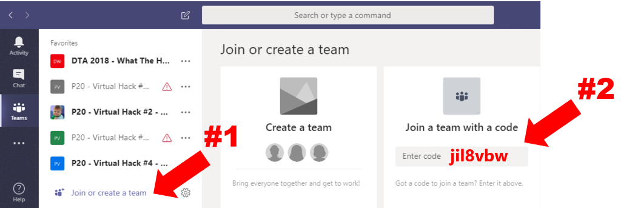
Once you have joined the team, get together as a team and think of a team name. Create a new channel with that name prefixed with your table number, so you have a place to collaborate, share helpful notes, and store files during today’s hack.
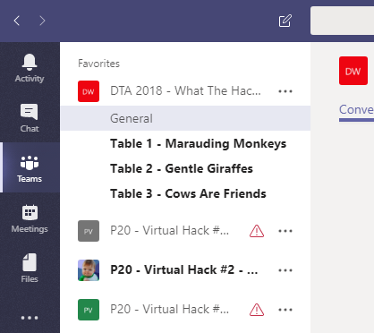

Will your team work together or individually? <hint: SWAG given for working together>
- Git for Windows – allows for working with Git repos locally on your machine as well as in VSTS. https://gitscm.com/downloads
- Determine Azure Subscription you will use for deployment

Resources
There are several folders in the Team site, including resources folders for each challenge.

Challenge 1: Intro to Spark
This challenge involves loading textual data in Azure blob storage (for this exercise, we will be using President Kennedy’s inaugural speech as our content source) and will use Spark - either python or scala (your choice) - to filter and transform the dataset according to the challenge summary.

Challenge Considerations
You will use Spark Resilient Distributed Datasets (RDDs) to load and explore data. The RDD-based API is an original module of Spark, and has largely been superseded by a newer Dataframe-based API;
however, there are many production systems (and code examples on the Web) that use RDDs, so it’s worth starting your exploration of Spark there.

Need help? If your team has done its research but is still struggling with this challenge & want to ‘cheat’, extract the zip file in the Team’s General channel file. See the 0_README.md file for guidance. Please use this option as a last ditch effort after exploring how other tables or members of your table are solving the challenge first.
Challenge Summary
Your team is preparing a proof of concept, and your group has been tasked to suggest answers to the following questions:

1. Can you determine the intent of President Kennedy’s speech <hint: look for words like freedom & create filtered views for those keywords to answer the question>
2. Are there any additional Spark concepts that you would use to help bring value to your analysis?
3. What are some potential ways you could save time during your analysis <hint: less lines of code following one API approach vs. another means faster time to value>
4. Are there any notable differences when analyzing Unstructured vs. Structured datasets?
Business Case 1a – Unstructured Analysis using President Kennedy’s Speech – <need to add link here>
- Setup assistance & Introduction to Azure Databricks concept <See 1_Setup.md in the Team site > - includes setting up Azure Blob Storage for data files that will be consumed during challenges

- Challenge 1.1: Setting up Azure Databricks: Create a cluster
- Challenge 1.2: Setting up Azure Databricks: Create a workspace & your first notebook
- Challenge 1.3: Use RDD API (python or scala) to transform unstructured data file from Azure Blob Storage

Business Case 1b – Structured Analysis of Traffic Accidents – <need to add link here>

- Challenge 1.4: Setting up Azure Databricks: Create new notebook & label it Dataframes.ipynb
- Challenge 1.5: Use Dataframes API (python or scale) (Spark 2.0) to analyze new STRUCTURED datasets (related to traffic accidents) : Read data in from Azure Blob storage
- Challenge 1.6: Create dataframes to analyze traffic patterns & vehicle densities by location;
- Challenge 1.7: Create top and bottom views of accident data to better under emerging patterns <if they exist>
- Challenge 1.8: Transform existing dataframes into Temporary Tables or Permanent Tables if your query results are deemed meaningful by your table using Spark SQL API

Follow up Activities:
- Discuss approaches and analysis with Table
- Load your Q&A and Feedback on your Teams site

