Intro
In this document, I detail how to take data from an Azure SQL MI database and copy it to a dedicated pool using a combination of the following two articles and some additional steps.
Incrementally copy data using Change Data Capture - Azure Data Factory | Microsoft Docs
Incrementally copy data from a source data store to a destination data store - Azure Data Factory | Microsoft Docs

Table of Contents
Intro 1
Prerequisites 1
Creating the incremental Copy Pipeline 3
Create the PipelineReference database 3
Creating the pipeline 4
Creating the Trigger SP Pipeline 14
Preparing the Tables 14
Creating the Stored Procedures 14
Creating the pipeline 20

Prerequisites
Steps taken to replicate the initial environment…
- We first create an AdventureWorksLT database in our Azure SQL MI instance. This can be achieved by utilizing the Adventure Works sample databases at https://docs.microsoft.com/en-us/sql/samples/adventureworks-install-configure?view=sql-server-ver15&tabs=ssms
- Next we need to create a blank AdventureWorks Dedicated SQL Pool on our Azure Synapse Instance.
- Within our AdventureWorks SQL Dedicated Pool we need to add the staging schema to the database. Within the Synapse Workspace, create a new SQL script under Develop. Point it to the SQL Dedicated Pool and copy the code below and run it.
CREATE SCHEMA SalesLT;
CREATE SCHEMA Staging
- We then copy the tables in the AdventureWorksLT database to our AdventureWorks Synapse Dedicated Pool using the Built-In copy task within Synapse… Copy Data tool - Azure Data Factory & Azure Synapse | Microsoft Docs
NOTE: This created all tables in the Dedicated Pool as ROUND ROBIN by Default. You may need to change these tables to Hash Distributed. You can do that using the CTAS command. For more on these topics check out the following.
Distributed tables design guidance - Azure Synapse Analytics | Microsoft Docs
CREATE TABLE AS SELECT (CTAS) - Azure Synapse Analytics | Microsoft Docs

- Now that we have 2 databases the are essentially the same, we will turn on Change Data Capture within the AdventureWorksLT SQL Azure Instance to track all inserts, updates and deletes so that they can be utilized in the incremental pipeline. For more on Data Capture check out What is change data capture (CDC)? - SQL Server | Microsoft Docs

Creating the incremental Copy Pipeline
We did not fully utilize the following instructions Incrementally copy data using Change Data Capture - Azure Data Factory | Microsoft Docs as we had some differences and also other factors to track.
- This assumes that the time window trigger is always running as expected and if the trigger fails or is accidentally deactivated, you will need to adjust your query to account for the larger time window. Because of that, I prefer using Watermarking. The basics of using watermarking with pipelines is defined here… Incrementally copy data from a source data store to a destination data store - Azure Data Factory | Microsoft Docs
- This accounts for writing to Azure Storage and we want to write to a dedicated SQL pool but we are writing to the staging tables of the dedicated pool. We will use a combination of Stored Procedures to update the production tables from the staging tables in the dedicated pool.

Create the PipelineReference database
Thus we are going to perform a few steps to create an incremental copy job. For this exercise we will just focus on the SalesLT.Address and SalesLT.Customer tables in the AdventureWorksLT Azure SQL instance. We used the following steps to get started.
- To begin we need to create another DB on our Azure SQL instance. I named the database PipelineReference and populated it with the two tables using the following scripts
  - Tablelookup: This is used to designate which tables will be copied from the SQL MI instance to the Dedicated Pool.
Use the script below to create the table
CREATE TABLE [dbo].[tablelookup](
[SourceTableSchema] [nvarchar](25) NOT NULL,
[SourceTableName] [nvarchar](100) NOT NULL,
[SourceCDCTableName] [nvarchar](150) NOT NULL,
[TargetTableSchema] [nvarchar](25) NOT NULL,
[TargetTableName] [nvarchar](100) NOT NULL
) ON [PRIMARY]
GO
You can also use the following script to populate the table.
INSERT INTO [dbo].[tablelookup]
([SourceTableSchema]
,[SourceTableName]
,[SourceCDCTableName]
,[TargetTableSchema]
,[TargetTableName])
VALUES
('SalesLT', 'Address', 'SalesLT_Address_CT', 'Staging', 'Address'),
('SalesLT', 'Customer', 'SalesLT_Customer_CT', 'Staging', 'Customer')
GO
  - Watermark table. We will use this to store our values needed for the incremental copy.
Use the script below to create the table

CREATE TABLE [dbo].[watermarktable](
[SourceCDCTableName] [varchar](150) NULL,
[WatermarkValue] [datetime] NULL
) ON [PRIMARY]
GO

You can use the following script to populate the table.

INSERT INTO [dbo].[watermarktable]
([SourceCDCTableName]
,[WatermarkValue])
VALUES
('SalesLT_Address_CT', '2021-10-22 00:00:00.000'),
('SalesLT_Customer_CT', '2021-10-22 00:00:00.000')

- Next we need to add the following stored procedure to the PipelineReference database.
CREATE PROCEDURE [dbo].[usp_write_watermark] @LastModifiedtime datetime, @TableName varchar(50)
AS

BEGIN

UPDATE watermarktable
SET [WatermarkValue] = @LastModifiedtime
WHERE [SourceCDCTableName] = @TableName

END
GO

Creating the pipeline
- Now we will create an initial pipeline with a lookup against our new tablelookup table and then execute a child pipeline based on the results.
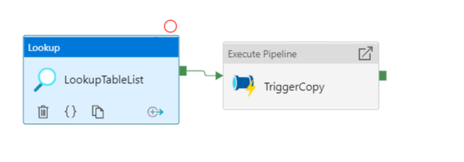
  - Create a pipeline and name it GetTableList-Trigger-Incremental-Copy
  - On the settings tab of the Lookup Activity and we want to set the following…
    - Source Dataset – Point to the PipelineReference Azure SQL database
    - Use Query: Query
    - Query: select * from [dbo].[tablelookup]
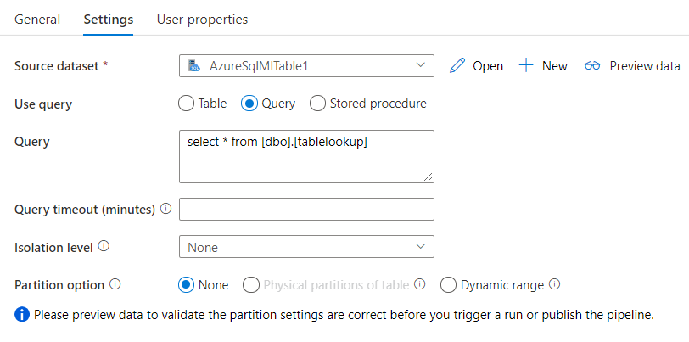
  - Publish this pipeline, we will add the Execute Pipeline step later.
- Now we will create our child pipeline that will take the lookup results from the PipelineReference database and loop through each set of tables to incrementally copy the changes to the staging tables of the Dedicated SQL Pool. Below are the various steps of the pipeline that we will create.
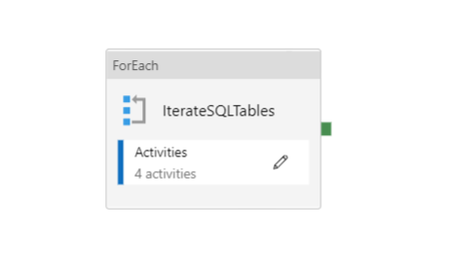
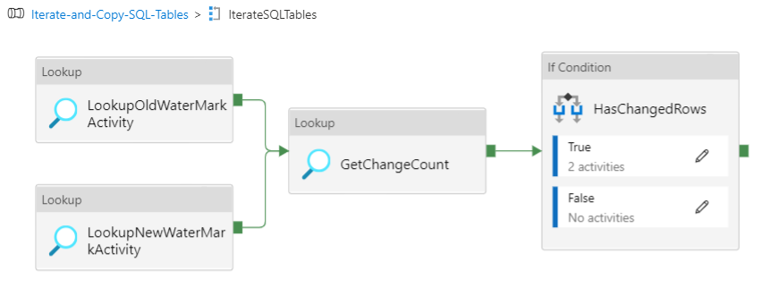
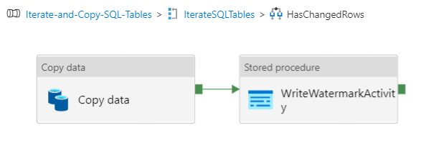

- Create a new pipeline and name it Iterate-and-Copy-SQL-Tables.
- In the Parameters tab of the pipeline add a New Parameter with the following values:
  - Name = tableList
  - Type=Array
  - Default Value should be blank. When blank you will see “Value”
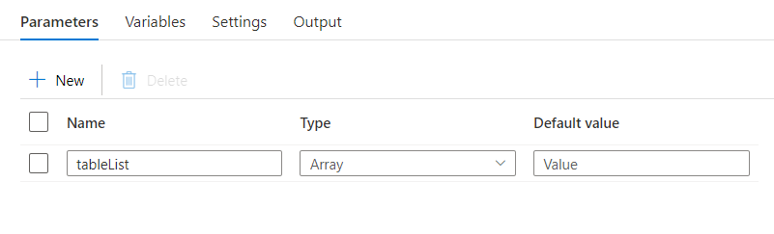
- Add a ForEach activity to the Pipeline canvas and name it IterateSQLTables
  - On the settings tab, set Items = @pipeline().parameters.tableList
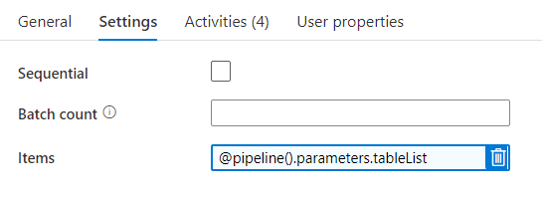
- In the ForEach control on the Activities tab, click the pencil to open the canvas specific to our ForEach activity. This is where we will write most of the logic.
- Add Three Lookup acitivites to the canvas of the IterateSQLTables ForEach activity.
  - For the first Lookup, name it LookupOldWaterMarkActivity.
Under Settings, we need to create a dataset that links to the Watermark table in the PipelineReference database on the Azure SQL instance that we created.
NOTE: This will also involve creating a Linked Service to the Azure SQL instance and then linking the dataset to that Linked Service.
    - Once created, set the new dataset equal to the PipelineReference dataset.
    - Use query: query
    - Query: select * from [dbo].[watermarktable] where [SourceCDCTableName] = '@{item().SourceCDCTableName}'
NOTE: This captures the last record updated in the previous pipeline run and will be used as our start date when querying for changes.
    - First row only: Checked
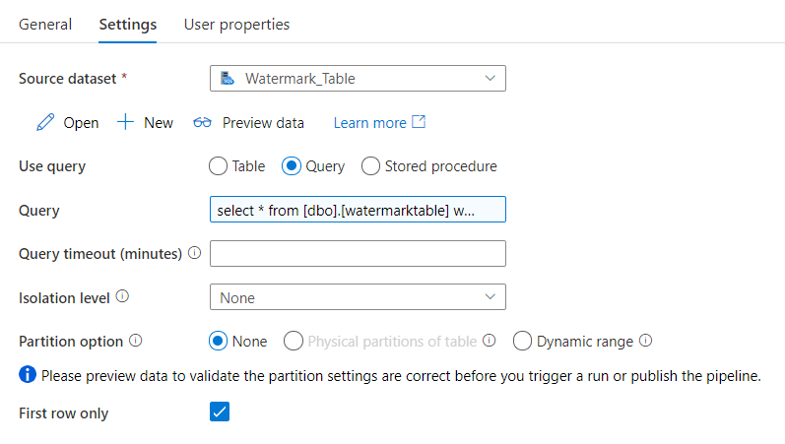
  - For the second Lookup, name it LookupNewWaterMarkActivity.
Under Settings, we need to create a new dataset that links to the AdventureWorksLT source database on the Azure SQL Instance
NOTE: This will also involve creating a Linked Service to the AdventureWorksLT Azure SQL instance and then linking the dataset to that Linked Service.
    - Once created, set the new dataset equal to the AdventureWOorksLT dataset.
    - Use query: query
    - Query: select MAX(TM.tran_begin_time) as NewWatermarkValue from [cdc].[@{item().SourceCDCTableName}] CDC INNER JOIN [cdc].[lsn_time_mapping] TM on CDC.__$start_lsn = TM.start_lsn
NOTE: We are using this query instead of the function utilized in the CDC Capture Incremental Copy Pipeline article referenced earlier. This query is based on the following…
select MAX(TM.tran_begin_time) as NewWatermarkValue from [cdc].[SalesLT_Customer_CT] CDC INNER JOIN [cdc].[lsn_time_mapping] TM on CDC.__$start_lsn = TM.start_lsn
This captures the most recent datetime field when the last cdc event was captured and we can use this to query for changed records as our end time.
    - First row only: Checked
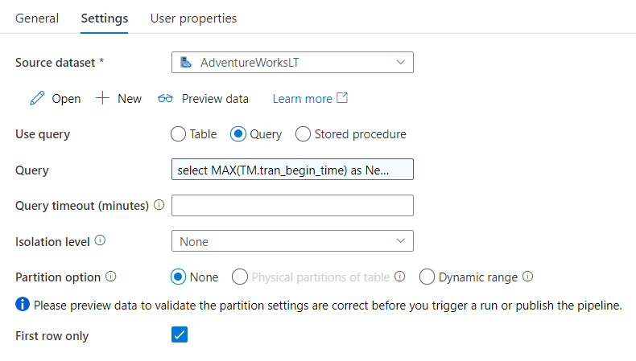
  - For the third Lookup, name it GetChangeCount.
    - Once created, set the new dataset equal to the dataset you used for the LookupNewWaterMarkActivity activity.
    - Use query: query
    - Query: select count(*) as changecount from [cdc].[@{item().SourceCDCTableName}] CDC INNER JOIN [cdc].[lsn_time_mapping] TM on CDC.__$start_lsn = TM.start_lsn
where tran_begin_time >
'@{activity('LookupOldWaterMarkActivity').output.firstRow.WatermarkValue}' and tran_begin_time <= '@{activity('LookupNewWaterMarkActivity').output.firstRow.NewWatermarkvalue}'
NOTE: We are using this query to determine if there are any new records residing in the CDC tables of the Azure SQL instance since the last time we ran this pipeline. If none exist, we will skip that table. This will be defined in the If Condition activity that we will build in the next steps.

    - First row only: Checked
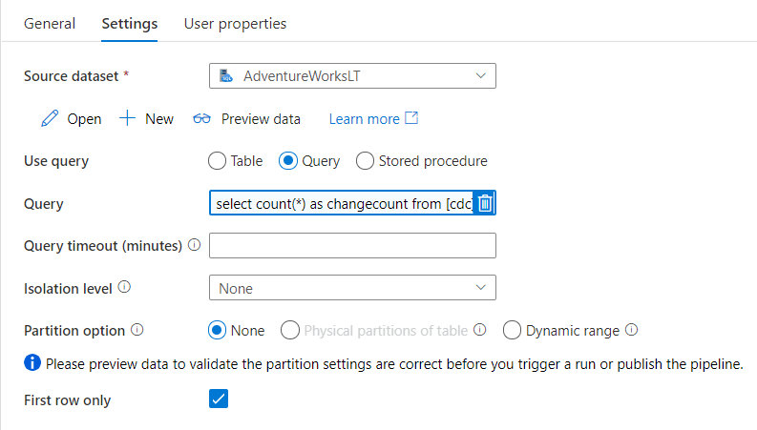
- Next arrange and link the lookups so that the LookupOldWaterMarkActivity and LookupNewWaterMarkActivity outputs feed into the GetChangeCount lookup like the picture below.
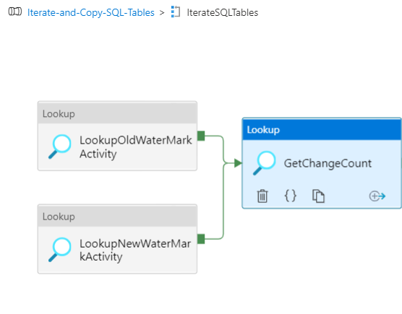
- Add an If Condition activity to the canvas to the right of GetChangeCount and name it HasChangedRows.
    - Link the output of GetChangeCount activity to the input of HasChangedRows.
    - On the Acitivites tab of the HasChangedRows activity, set the expression to
@greater(int(activity('GetChangeCount').output.firstRow.changecount),0)
NOTE: This will trigger a true or false based on the row count. If we have data in the CDC tables newer than the old water mark, it will trigger a true activity.
- Click the pencil on the True Activity Listing of the Activities tab to activate a new canvas under the HasChangedRows activity. Up top, your breadcrumbs should look like the following.
- Now add a Copy data activity to the canvas and set the following values
  - Source Tab
    - Set the Source Dataset to the same dataset you used for the LookupNewWaterMarkActivity and GetChangedRows activities.
    - Use query: Query
    - Query: select CDC.*, TM.tran_begin_time from [cdc].[@{item().SourceCDCTableName}] CDC INNER JOIN [cdc].[lsn_time_mapping] TM on CDC.__$start_lsn = TM.start_lsn
where tran_begin_time >
'@{activity('LookupOldWaterMarkActivity').output.firstRow.WatermarkValue}' and tran_begin_time <= '@{activity('LookupNewWaterMarkActivity').output.firstRow.NewWatermarkvalue}'
NOTE: We are using this query to get all values for any new records residing in the CDC tables of the Azure SQL instance since the last time we ran this pipeline.
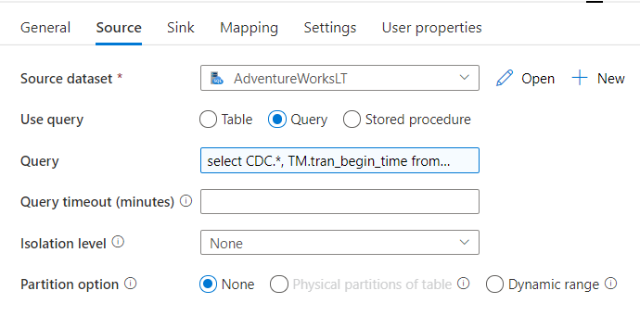
  - Sink Tab
    - For Sink dataset, we need to create a new dataset that is linked to our Dedicated SQL Pool with the following values
      - Connection Tab
        - SQL pool: AdventureWorks
NOTE: This is our target database
        - Table: @dataset().DWTableSchema.@dataset().DWTableName
        - Edit: Checked.
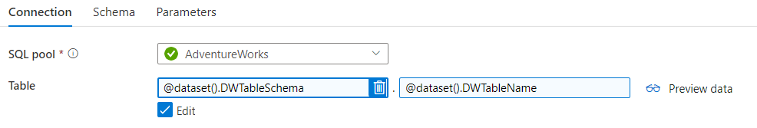
      - Parameters Tab
Create two parameters with the following values.
Name | Type | Default Value
DWTableSchema | String | Leave Blank
DWTableName | String | Leave Blank
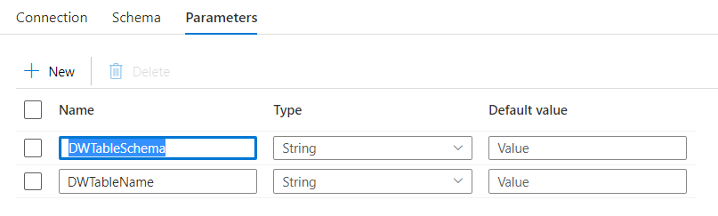
    - Set this new dataset to your sink dataset value on the Sink tab of the True activities canvas
    - Under the Dataset properties set the following values
      - DWTableSchema: @{item().TargetTableSchema}
      - DWTableName: @{item().TargetTableName}
    - Copy Method: Bulk Insert
NOTE: For this example we are using Bulk Insert to auto create the tables. In production scenarios we would recommend that after the tables are created to use either COPY or Polybase which will requires Staging data in a storage account. For more on this topic see
Copy and transform data in Azure Synapse Analytics - Azure Data Factory & Azure Synapse | Microsoft Docs
    - Table option: Auto create table
NOTE: This will create the table with a Round Robin Distribution
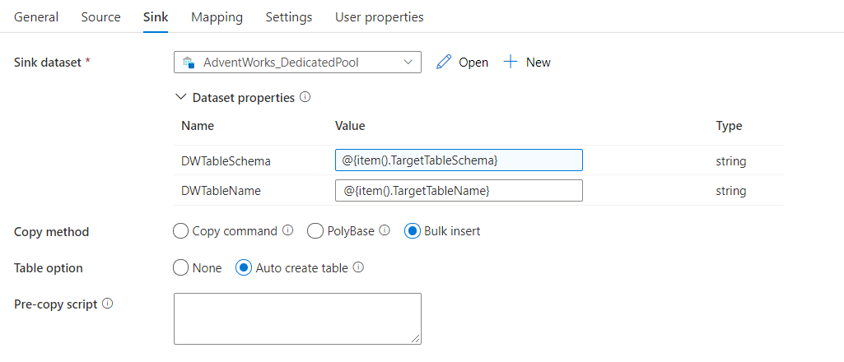

- Next add a Stored Procedure Activity to the canvas to the right of the Copy data activity and name it WriteWatermarkActivity. Link the output of the Copy data activity to the input of the WriteWatermarkActivity so that it looks like the screenshot below.
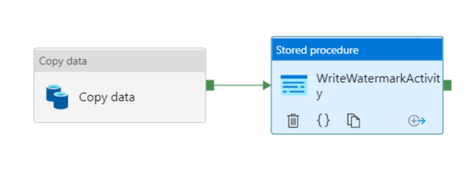
  - Under the Settings tab of the WriteWatermarkActivity set the following values:
    - Linked Service: This is tied to the PipelineReference database of your Azure SQL Instance.
    - Stored procedure name: [dbo].[usp_write_watermark]
    - Edit: Checked
      - Add 2 Stored Procedure Parameters
Name | Type | Value
LastModifiedtime | Datetime | @{activity('LookupNewWaterMarkActivity').output.firstRow.NewWatermarkvalue}
TableName | String | @{activity('LookupOldWaterMarkActivity').output.firstRow.SourceCDCTableName}

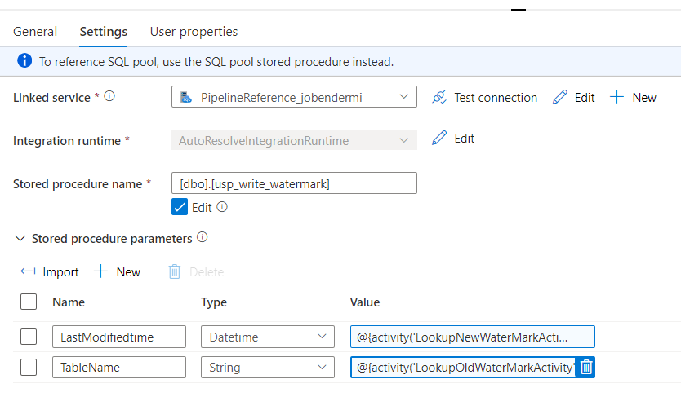
- Next we want to click back to the beginning of the breadcrumbs so we are at the root of the Iterate-and-Copy-SQL-Tables pipeline.
- Now reopen the GetTableList-Trigger-Incremental-Copy pipeline and add an Execute Pipeline activity to the right of the LookupTableList activity and name it TriggerCopy.
  - On the Settings tab, set the following values
    - Invoked Pipeline: Iterate-and-Copy-SQL-Tables
    - Wait on completion: Checked
    - Parameters
Name | Type | Value
tableList | array | @activity('LookupTableList').output.value

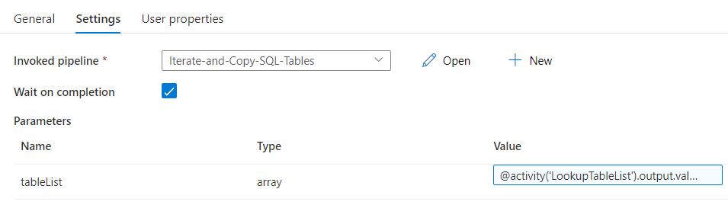
- Link the output of the LookupTableList activity to the input of the TriggerCopy so the canvas looks like the following.
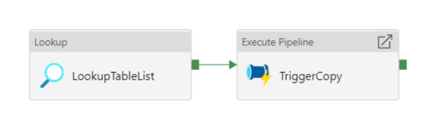
- Publish your pipelines, datasets, etc.
- Now we can test this by adding, updating and deleting records from the SalesLT.Address and SalesLT.Customer tables in the AdventureWorksLT SQL instance.
- When you do the previous step, it will create new rows under the system tables of [cdc].[SalesLT_Address_CT] and [cdc].[SalesLT_Contact_CT] tables. To understand the values in these tables check out
What is change data capture (CDC)? - SQL Server | Microsoft Docs

- Open the GetTableList-Trigger-Incremental-Copy and trigger the pipeline. When complete you should now have two new tables in your dedicated pool named [Staging].[Address] and [Staging].[customer].

- You will also notice that the watermark values have been updated in the PipelineReference Azure SQL instance. To evaluate these run the following SQL script.
select * from [dbo].[watermarktable]

In the next section we will create the stored procedures and pipeline to copy the data from the staging tables to the production tables within the SQL Dedicated Pool.

Creating the Trigger SP Pipeline

Preparing the Tables
In preparation for the subsequent steps, we need to add 2 fields to each of the production tables within the SQL Dedicated Pool. These are __$operation and tran_begin_time and these will be used to evaluate rows in advanced delete and other scenarios. Here are commands for the Address and Contact tables.
ALTER TABLE [SalesLT].[Address]
ADD [__$operation] [int] NULL,
[tran_begin_time] [datetime] NULL;

ALTER TABLE [SalesLT].[Customer]
ADD [__$operation] [int] NULL,
[tran_begin_time] [datetime] NULL;

Creating the Stored Procedures
These will be utilized in the subsequent pipeline we create. Because this could be set on a rolling window, a record could be added, updated and deleted in the source Azure SQL database during that window. Thus, we will create 3 stored procedures per entity:
- Insert
- Update
- Delete
These are fired by one master Stored Procedure which we will trigger from the pipeline created later in this section.
- Create the following spInsert Stored Procedures in the AdventureWorks SQL Dedicated Pool.
  - SalesLT.spInsertAddress
IF OBJECT_ID ( 'SalesLT.spInsertAddress', 'P' ) IS NOT NULL
DROP PROCEDURE SalesLT.spInsertAddress;
GO

CREATE PROCEDURE SalesLT.spInsertAddress

AS
BEGIN
SET NOCOUNT ON;
INSERT SalesLT.Address
(
AddressID
, AddressLine1
, AddressLine2
, City
, StateProvince
, CountryRegion
, PostalCode
, rowguid
, ModifiedDate
, __$operation
, tran_begin_time
)
SELECT
AddressID
, AddressLine1
, AddressLine2
, City
, StateProvince
, CountryRegion
, PostalCode
, rowguid
, ModifiedDate
, __$operation
, tran_begin_time

from Staging.Address S1
where NOT EXISTS (SELECT AddressID FROM SalesLT.Address S2 WHERE S2.AddressID = S1.AddressID)
and S1.__$operation = 2
;
END;
GO

  - SalesLT.spInsertCustomer
IF OBJECT_ID ( 'SalesLT.spInsertCustomer', 'P' ) IS NOT NULL
DROP PROCEDURE SalesLT.spInsertCustomer;
GO

CREATE PROCEDURE SalesLT.spInsertCustomer

AS
BEGIN
SET NOCOUNT ON;
INSERT SalesLT.Customer
(
CustomerID
, NameStyle
, Title
, FirstName
, MiddleName
, LastName
, Suffix
, CompanyName
, SalesPerson
, EmailAddress
, Phone
, PasswordHash
, PasswordSalt
, rowguid
, ModifiedDate
, __$operation
, tran_begin_time
)
SELECT
CustomerID
, NameStyle
, Title
, FirstName
, MiddleName
, LastName
, Suffix
, CompanyName
, SalesPerson
, EmailAddress
, Phone
, PasswordHash
, PasswordSalt
, rowguid
, ModifiedDate
, __$operation
, tran_begin_time

from Staging.Customer S1
where NOT EXISTS (SELECT CustomerID FROM SalesLT.Customer S2 WHERE S2.CustomerID = S1.CustomerID)
and S1.__$operation = 2
;
END;
GO

- Create the following spUpdate Stored Procedures in the AdventureWorks SQL Dedicated Pool.
  - SalesLT.spUpdateAddress
IF OBJECT_ID ( 'SalesLT.spUpdateAddress', 'P' ) IS NOT NULL
DROP PROCEDURE SalesLT.spUpdateAddress;
GO

CREATE PROCEDURE SalesLT.spUpdateAddress

AS
BEGIN
SET NOCOUNT ON;
UPDATE SalesLT.Address
SET
AddressID = S1.AddressID
, AddressLine1 = S1.AddressLine1
, AddressLine2 = S1.AddressLine2
, City = S1.City
, StateProvince = S1.StateProvince
, CountryRegion = S1.CountryRegion
, PostalCode = S1.PostalCode
, rowguid = S1.rowguid
, ModifiedDate = S1.ModifiedDate
, __$operation = S1.__$operation
, tran_begin_time = S1.tran_begin_time

from Staging.Address S1
where [SalesLT].[Address].AddressID = S1.AddressID
and S1.__$operation = 4
and S1.tran_begin_time = (select MAX(s2.tran_begin_time) from Staging.Address s2 where s2.addressid=s1.addressid and S2.__$operation in (4))
;
END;
GO
  - SalesLT.spUpdateCustomer
IF OBJECT_ID ( 'SalesLT.spUpdateCustomer', 'P' ) IS NOT NULL
DROP PROCEDURE SalesLT.spUpdateCustomer;
GO

CREATE PROCEDURE SalesLT.spUpdateCustomer

AS
BEGIN
SET NOCOUNT ON;
UPDATE SalesLT.Customer
SET
NameStyle = S1.NameStyle
, Title = S1.Title
, FirstName = S1.FirstName
, MiddleName = S1.MiddleName
, LastName = S1.LastName
, Suffix = S1.Suffix
, CompanyName = S1.CompanyName
, SalesPerson = S1.SalesPerson
, EmailAddress = S1.EmailAddress
, Phone = S1.Phone
, PasswordHash= S1.PasswordHash
, PasswordSalt = S1.PasswordSalt
, rowguid = S1.rowguid
, ModifiedDate = S1.ModifiedDate
, __$operation = S1.__$operation
, tran_begin_time = S1.tran_begin_time

from Staging.Customer S1
where [SalesLT].[Customer].CustomerID = S1.CustomerID
and S1.__$operation = 4
and S1.tran_begin_time = (select MAX(s2.tran_begin_time) from Staging.Customer s2 where s2.Customerid=s1.Customerid and S2.__$operation in (4))
;
END;
GO

- Create the following spDelete Stored Procedures in the AdventureWorks SQL Dedicated Pool.
  - SalesLT.spDeleteAddress
IF OBJECT_ID ( 'SalesLT.spDeleteAddress', 'P' ) IS NOT NULL
DROP PROCEDURE SalesLT.spDeleteAddress;
GO

CREATE PROCEDURE SalesLT.spDeleteAddress

AS
BEGIN
SET NOCOUNT ON;

DELETE FROM S2
FROM SalesLT.Address S2
INNER JOIN [Staging].[Address] S1
ON S2.AddressID = S1.AddressID
Where S2.AddressID = S1.AddressID
and S1.__$operation = 1
;
END;
GO

  - SalesLT.spDeleteCustomer
IF OBJECT_ID ( 'SalesLT.spDeleteCustomer', 'P' ) IS NOT NULL
DROP PROCEDURE SalesLT.spDeleteCustomer;
GO

CREATE PROCEDURE SalesLT.spDeleteCustomer

AS
BEGIN
SET NOCOUNT ON;

DELETE FROM S2
FROM SalesLT.Customer S2
INNER JOIN [Staging].[Customer] S1
ON S2.CustomerID = S1.CustomerID
Where S2.CustomerID = S1.CustomerID
and S1.__$operation = 1
;
END;
GO

- Last of all we need to create the master Stored Procedure that will use Dynamic SQL to execute the SPs we just created in the previous steps. This master stored procedure will be triggered by the pipeline we are going to create in the subsequent steps.
IF OBJECT_ID ( 'SalesLT.spInsertUpdateDelete', 'P' ) IS NOT NULL
DROP PROCEDURE SalesLT.spInsertUpdateDelete;
GO

CREATE PROC [SalesLT].[spInsertUpdateDelete]
(
@TableSchema VARCHAR(50),
@TableName VARCHAR(50)
)

AS
DECLARE @sqlInsert AS NVARCHAR(4000)
DECLARE @sqlUpdate AS NVARCHAR(4000)
DECLARE @sqlDelete AS NVARCHAR(4000)
DECLARE @sqlTruncate AS NVARCHAR(4000)

SELECT @sqlInsert = 'EXEC ' + @TableSchema + '.spInsert' + @TableName + ''
EXEC(@sqlInsert)

SELECT @sqlUpdate = 'EXEC ' + @TableSchema + '.spUpdate' + @TableName + ''
EXEC(@sqlUpdate)

SELECT @sqlDelete = 'EXEC ' + @TableSchema + '.spDelete' + @TableName + ''
EXEC(@sqlDelete)

SELECT @sqlTruncate = 'TRUNCATE TABLE Staging.' + @TableName + ''
EXEC(@sqlTruncate)
GO

Creating the pipeline
Now that we have the stored procedures created, we can create the Synapse Pipeline to execute them on an automated basis. The purpose of the pipeline is to scroll through the staging tables defined in the dbo.tablelookup table of the PipelineReference database. If we find data in the staging tables, the stored procedure will perform the following actions in the following order…
- Insert Records with __$operation = 2
- Update Records with __$operation = 4.
NOTE: We will take only the max record for each table grouped by unique ID and MAX(tran_begin_time).
- Delete Records with __$operation = 1
- Truncate the staging table

- Now we will create an initial pipeline with a lookup against the tablelookup table in the PipelineReference Azure SQL database and then execute a child pipeline based on the results.
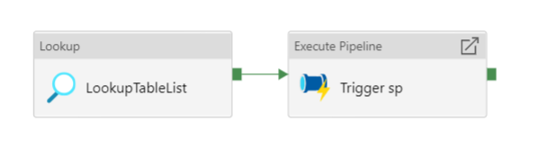
  - Create a pipeline and name it GetTableList-Trigger-sp
  - On the settings tab of the Lookup Activity and we want to set the following…
    - Source Dataset – Point to the PipelineReference Azure SQL database
    - Use Query: Query
    - Query: select * from [dbo].[tablelookup]
  - Publish this pipeline, we will add the Execute Pipeline step later.
- Now we will create our child pipeline that will take the lookup results and loop through each set of tables to incrementally copy the changes to the staging tables of the dedicated pool. Below are the various steps of the pipeline that we will create.
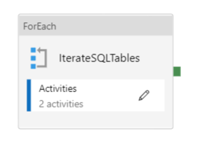
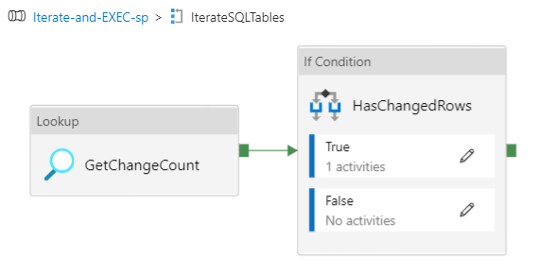
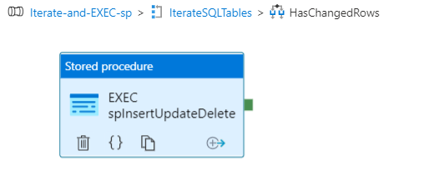
- Create a new pipeline and name it Iterate-and-EXEC-sp.
- In the Parameters tab of the pipeline add a New Parameter with the following values:
  - Name = tableList
  - Type=Array
  - Default Value should be blank. When blank you will see “Value”
- Add a ForEach activity to the Pipeline canvas and name it IterateSQLTables
  - On the settings tab, set Items = @pipeline().parameters.tableList
- In the ForEach control on the Activities tab, click the pencil to open the canvas specific to the ForEach activity. This is where we will write most of the logic.
- Add a Lookup activity to the canvas of the IterateSQLTables ForEach activity and name it GetChangeCount.
    - Under the Settings tab, create a new Dataset that points to the AdventureWorks SQL Dedicated Pool. Under the connection tab of the dataset, select the Dedicated SQL pool and leave the Table blank.
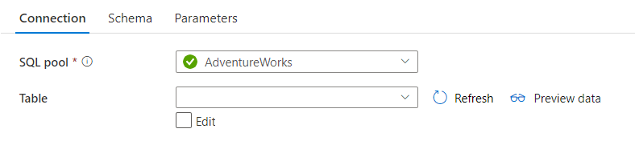

    - Back on the GetChangeCount settings tab, select the following values:
      - SQL pool: AdventureWorks
      - Use query: query
      - Query: select count(*) as changecount from [@{item().TargetTableSchema}].[@{item().TargetTableName}]
NOTE: We are using this query to determine if there are any new records residing in the staging table of the Dedicated SQL Pool. If none exist, we will skip that table. This will be defined in the If Condition activity that we will build in the next steps.
      - First row only: Checked
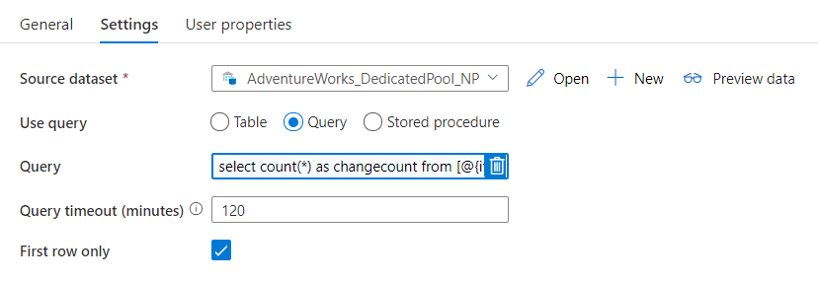
- Add an If Condition activity to the canvas to the right of GetChangeCount and name it HasChangedRows.
  - Link the output of GetChangeCount activity to the input of HasChangedRows.
  - On the Acitivites tab of the HasChangedRows activity, set the expression to
@greater(int(activity('GetChangeCount').output.firstRow.changecount),0)
NOTE: This will trigger a true or false based on the row count. If we have data in the staging table, it will trigger a true activity.
- Click the pencil on the True Activity Listing of the Activities tab to activate a new canvas under the HasChangedRows activity. Up top, your breadcrumbs should look like the following.
- Next add a Stored Procedure Activity to the canvas and name it EXEC spInsertUpdateDelete.
  - Under the Settings tab set the following values:
    - Linked Service: This is tied to the Synapse Instance
    - DB Name: AdventureWorks
    - Stored procedure name: [SalesLT].[spInsertUpdateDelete]
    - Edit: Checked
      - Add 2 Stored Procedure Parameters
Name | Type | Value
TableSchema | String | @{item().SourceTableSchema}
TableName | String | @{item().SourceTableName}

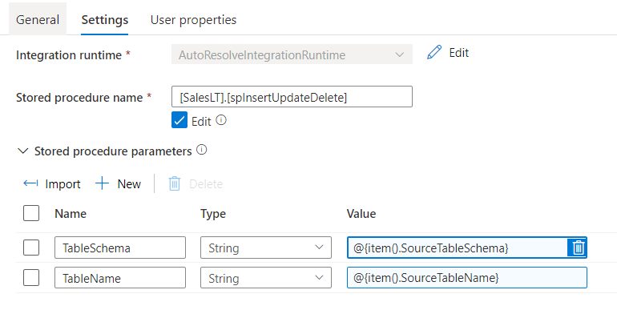
- Next we want to click back to the beginning of the breadcrumbs so we are at the root of the Iterate-and-Exec-sp pipeline.
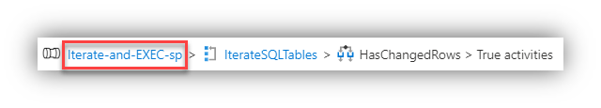
- Now reopen the GetTableList-Trigger-sp pipeline and add an Execute Pipeline activity to the right of the LookupTableList activity and name it Trigger sp.
  - On the Settings tab, set the following values
    - Invoked Pipeline: Iterate-and-Exec-sp
    - Wait on completion: Checked
    - Parameters
Name | Type | Value
tableList | array | @activity('LookupTableList').output.value
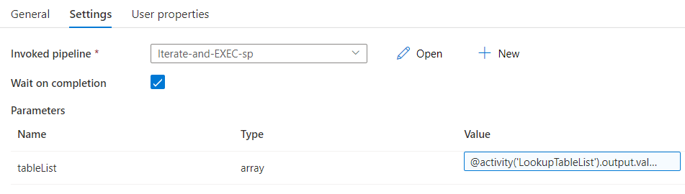
- Link the output of the LookupTableList activity to the input of the Trigger sp activity so the canvas looks like the following.
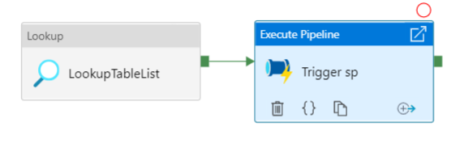
- Publish your pipelines, datasets, etc.
- Now we can test this pipeline. If the previous pipeline of GetTableList-Trigger-Incremental-Copy completed successfully, we should have records in the Staging.Address and Staging.Customer tables in the AdventureWorks SQL Dedicated Pool.
NOTE: If these records do not exist, nothing will happen when we trigger this pipeline.
- Open the GetTableList-Trigger-sp and trigger the pipeline.
  - When complete you should now have new rows in the [SalesLT].[Address] and [SalesLT].[Customer] tables of the AdventureWorks SQL Dedicated Pool.
  - Also there should be no rows in the [Staging].[Address] and [Staging].[customer] tables of the AdventureWorks SQL Dedicated Pool as the last step of the stored procedure truncates these tables.

