Bonsai Brain - AI Solution Spec
Authors: [Solution Architects name]
Customer | MineCo Crusher Optimization
Project Summary  What task/process are you looking to improve using deep reinforcement learning? | - Company 1 line overview: MineCo mines precious metals from ore.​  - Process summary: The first and roughest stage of ore processing is crushing the ore, in this case with a gyratory crusher. ​  - How is it controlled today: Operators manually control supervisory settings for the gyratory crusher. ​  - What makes it difficult to control: The particle size and hardness entering the crusher and the crusher itself, particularly the condition of the liner, vary with an unknown random distribution. This makes it very difficult to control the crusher well. ​​  - Simulation: There is an existing simulation which will be adapted for this project.  - Project objective: The objective of this project is to train a brain(s) to provide supervisory control settings for the underground gyratory crushers at the MineCo South site that maximize the throughput of fragmented ore. ​  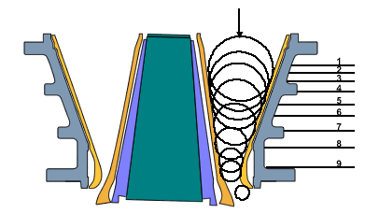  Figure 1: Crusher Schematic
Business Value  What is the business value of improving the control/ optimization of this system? | This use case is understood to bring approximately 1million USD of benefit.  Description Customer owner  Benchmark Comparison: The brain will be compared to a human operator. Jane Doe  Do historical benchmarks exist: Yes, there has been extensive work in this space. John Doe
Optimization Goals  What Key Performance Indicators (KPI) define the control or optimization of this system? | Priority Goal (KPI) Units Description  1 Maximize Throughput tons/hour The amount of material that passes through the crusher on to high pressure grinding rolls (HPGR) having met the 65mm fineness criteria for particle size.  2a Maximise Efficiency tons/hour Depending on customer demand. The crusher must sometimes run-in efficiency mode. This is a secondary priority to maximising throughput.  2b Minimise waste tons/hour As part of maximising efficiency, waste material must be reduced.

Current Methods  How do you currently control or optimize the system? | Method Level  Human Operator / Engineer Supervisory Control: The fixed plant team currently gaps the crushers once every 24 hours. This leads to sub-optimal results and is time intensive.  Expert System  Control Theory (PID, MPC) Low-Level Control: The APC system utilizes both PID and MPC control systems.  Optimization Techniques
Limitations of Current Methods  What are the challenges and limitations of the current method(s)? | Metallurgists create and modify recipes that are used by the operators to determine the supervisory setpoints under various conditions.  Limitation Description  Multiple or changing optimization goals  Uncertainty in the measurement of the inputs or the process make it difficult to control or optimize. The particle size distribution and the hardness distribution of the incoming ore is unknown.  Time to develop control or optimization system is prohibitive  Control system has difficulty managing many variables and dimensions.  Human operators find it difficult to adapt to changing conditions Human operators find it difficult to manage the changing particle size distribution and the changing hardness distribution of the incoming ore.  Large performance discrepancy between novice and expert operators Expert operators gain expertise over many years.  Inconsistency across expert operators

Heuristics  We use subject matter expertise to help determine the solution architecture of the brain. | When the [environment variable list] trend in this direction or interact in this way, This is what we think it means. This is what you should do (to manipulate control actions).  If incoming particle sizes are larger and / or ore is harder More compression is required Choke the crusher  If incoming particle sizes are smaller and / or ore is softer This is a higher throughput opportunity Regulate the crusher  If the crusher is getting too full, especially with smaller particles. You may bog (clog up) the crusher in which case it will need to be stopped and manually unclogged. Slow down the feed into the crusher

Concept Network Decomposition
Brain(s) can be decomposed into one or more subcomponent concepts as needed.

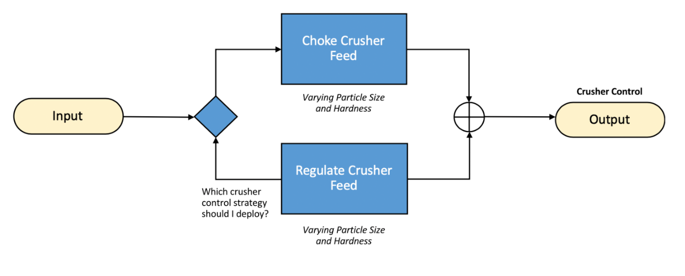

Deep Reinforcement Learning  For each concept that we will train using DRL, we outline the sequential decision | For each concept that we will train using Deep Reinforcement Learning, we outline the sequential decision:  Concept Actions (see Control Actions table for details) States (see Environment States table for more details) Reward (see Environment States table for more details) Scenarios (see Environment States table for more details)  Maximise Crusher usage ROM feeder speed, crusher gap setpoint and throat level. Ore throughput passing through the particle sieve changes. Maximise Throughput Particle Size Distribution Ore Hardness Distribution  Keep Crusher usage within range ROM feeder speed, crusher gap setpoint and throat level. Ore throughput passing through the particle sieve changes. Match Throughput Particle Size Distribution Ore Hardness Distribution
Constraints  What constraints are placed on the control actions by the system or the process? | - Engineering limit on the Mantle Height: 25mm to 275mm. Control actions that result in mantle heights of less than 30mm should not be used for safety.  - Maximum crusher gap change allowed per hour is 15mm.
Control Actions  What actions will the brain need to output to control or optimize your system? | Level Number of Actions Description  Supervisory 3 The brain will provide supervisory set points.  Low-level Low-level control will remain with the APC controllers.  Name Approximate Range Description  ROM Feeder Speed [0-100] with steps of 5 The speed of the crusher feeder; this dictates how much ore is coming into the crusher.  Crusher Gap Setpoint [10-20] with steps of 1 The setpoint for the smallest distance (gap) between between the mantle liner and concave liner on the closed side The crusher gap is currently changed in minimum increments of 10mm. For example, if the gap needs to be changed by 5mm, it will be increased by 15mm and then decreased by 10mm.  Throat Level [80-100] with steps of 5 Vertical distance between the top of the crusher and the crusher gap  Control frequency of above actions (explain if different): hourly (once per hour))
Environment States  What information do we need to pass to the brain about the system and its environment for the brain to learn to control or optimize the system? | Name Approximate range Description  ROM Bin Level [50-100] Percent of capacity that the ROM bin is filled  ROM Feeder Speed [50-100] The speed of the feeder delivering uncrushed rock into the crusher​  COB Bin Level [50-100] Percent of capacity that the Crushed Ore Bin (COB) bin is filled  COB Low/High Microwave Sensors [50-100] Sensors for determining if the COB is either approaching full or empty. Will trigger stops for feeder conveyor belts when reached.​  COB Feeder Speed [50-100] The speed of the feeder delivering uncrushed rock out of the COB bin to the main conveyor​  Throughput [50-200] The amount of ore that passes through the crusher and goes to HPGR having met the 65mm quality criteria.  Weight-o-meter [0-200] The amount of ore that leaves the crushed ore bin  Fragmentation [0-100] Ore size as reported by ore size camera  Current Gap Setpoint [10-20] The setpoint for the smallest distance (gap) between between the mantle liner and concave liner on the closed side  Throat Box Sensor [60-100] Provides an indication of the rock level within the crusher  Crusher Power [10-100] Power delivered to operate the crusher  Mantle Height [50-100] The linear height of the hydraulics controlling the crusher gap width as measured by the mantle linear sensor  Crusher liner wear [0-100]  Demand predictions [0-100] Amount of ore expected to be mined  Surface Expected [0-10] Amount of ore expected on the surface  Ore Type Prediction [0-3] Type of ore expected  Measurement frequency of above states: minute (once per minute)  Confirm measurement frequency of above states matches control frequency of actions: No  Confirm all states are/will be available within the simulation: Yes  Confirm all states are/will be available for deployment: Yes  Delayed Reward Scenario: It takes a matter of minutes for most ore to move through the crusher and 15 minutes to get an average fragmentation time. We do not have a delayed reward scenario.  Rule of thumb: For optimal learning, system should settle to steady state within 1/10th of the control frequency.

Simulation Model Method | Method Description  Physics Based (First Principles)  Discrete Event  Surrogate Model  Model from Data [See excel template]
Simulation  Readiness | Does the simulation exist? Yes  How has the simulation been used? It has been used to build an MPC  Sim Builder MineCo  Sim Vendor Simulink  Sim Validation Project would include data collection exercise that can be used to validate the sim.  Product (Version) N/A, custom sim  Sim speed Less than 1 second per iteration  Any sim warm up time? Yes – approximately 15 mins  Availability of programmatic interface Yes  Any licensing concerns to run 100s of copies in Azure? No  Sim operating system NA – Simulink scales natively in Bonsai  Additional sim work to start a Bonsai project Need to add an existing PID to the sim.
Supplementary Decision Models | Type Description  Liner Predictor [description]  ROM Bin Input Predictor [description]  COB Bin Output Predictor [description]  Rock Hardness Fragmentation Predictor [description]  Maximum Safe Crusher Gap Predictor description]

Deployment approach  Understand the deployment process | Phases in deployment: There will be a gated deployment.  Description of first phase: First a ‘read only’ deployment pulling data from the machine and providing the suggested action to the operator.  Success criteria to move past first phase: Once the above is considered successful (<1 week trial) there will be potential for a further project.
Deployment Interface  Option 1 - Decision Support  Human engineers, operators or analysts will continue to control and automate my system augmented by brain decisions. | Cloud Deployment  Edge Deployment  Embedded Deployment  For Edge and Embedded Deployments, a separate generalised architectural diagram will be discussed.  Decision Delivery Mechanism Description (including owner and read only or read/write)  New Decision Support UI  Existing Decision Support UI  Spreadsheet or other mechanism
Deployment Interface  Option 2 – Direct Control  The brain will connect to the system directly to automate the control or optimization. | The brain will connect to the system directly to automate the control or optimization.  Cloud Deployment  Edge Deployment  Embedded Deployment  For Edge and Embedded Deployments a separate generalised architectural diagram will be discussed.
Real World Trials and production | Success criteria required to go to real world trials  Success criteria required to go to production  Does the customer desire post-production maintenance and support?  Where will the real-world trials be conducted?  Are there any limitations on our ability to perform real-world trials?  Are there any safety considerations?  Does the customer want help with Change Management?

